­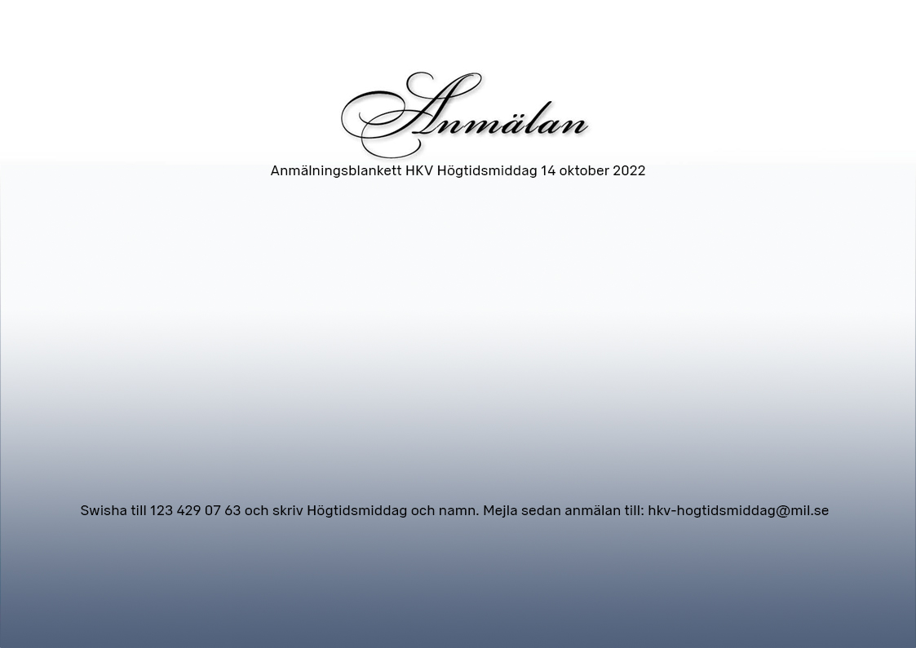

|  |  |  |  |  |  |
| --- | --- | --- | --- | --- | --- |
| Namn | Personnummer | Ev matallergi/  ev annan kost | Önskar alkoholfri dryck | Enhet/Avd (motsv) | Telefonnummer |
|  |  |  |  |  |  |
|  |  |  |  |  |  |